**Tanvi Ramesh Manchekar**

**SYBScIT**

**232**

**Vintage Car Showroom**

**1.Project Objective and Scope:**

Provide detailed information, including high-quality images and descriptions of the vintage cars available at the showroom.Facilitate customer interaction through features like inquiries, newsletters, and appointment scheduling for showroom visits or test drives.Present a professional and aesthetically appealing website that reflects the unique style and exclusivity of vintage cars.Integrate e-commerce functionality for purchasing or placing deposits on vintage car.Offer resources like blog posts, videos, or guides about vintage car restoration, maintenance, and history.Connect with social media platforms to expand visibility and share updates.

**Scope:**

* Introduction to the vintage car showroom.
* Highlights of featured cars.
* High-quality image gallery.
* Car details: model, year, specifications, price.
* Multiple images from different angles.
* Detailed descriptions (history, restoration details, engine info, etc.).
* Inquiry form for interested buyers.

**2.Technologies Used:**

* HTML
* CSS
* JavaScript

**3.User Guide For Website Navigation and Usage:**

**3.1 Home Page**

A full-width, high-resolution image or video of featured vintage cars.

Headline: “Discover the Finest Collection of Vintage Cars.”

Easy access to key pages like “Cars for Sale,” “About Us,” “Services,” and “Contact”.Highlight 3-4 top or newly arrived vintage cars with quick-view options (photos, make, model, year).

**3.2About Us**

A compelling story about how the showroom started, emphasizing a passion for vintage cars. Highlight any founders or notable experts involved. Explain the showroom’s commitment to quality, customer service, and preserving automotive history. Introduce key members of the team with short profiles and images. Include their roles and expertise (especially relevant if they are experts in car restoration or history). Mention any awards, milestones, or partnerships with classic car clubs or events.

**3.3 Service Page**

Detail car restoration process: from bodywork and engine restoration to upholstery and detailing. Explain the routine maintenance services you offer, from oil changes to complex engine repairs. Describe how you help clients find rare or specific vintage cars. Include details about your network of dealers, auctions, and collectors.

**4.Testing and Validation Process:**

|  |  |  |  |  |
| --- | --- | --- | --- | --- |
| **Phase** | **Objective** | **Testing Activitie** | **Tools/Methods** | **Expected Outcome** |
| 1.Functional Testing | Ensure all features work as intended. | Test individual features such as car inquiry froms, booking, etc. | Manual Testing, Selenium. | All features work as expected with out errors or broken functionalities. |
| 2.Usability Testing | Validateease of use and intuitive navigation. | Test user flow for searching cars, booking test drives, making inquiries. | User Testing, Heuristic Evaluation. | Users can complete actions easily with out confusion or road blocks. |
| 3.Security Testing | Ensure website security and data protection. | Test for vulnerabilities like SSL certificate, secure logins, data protection. | OWASP, SSL Labs, Penetration testing. | Website is protected from common threats like SQL injection, XSS, etc. |

**Slide Show:**

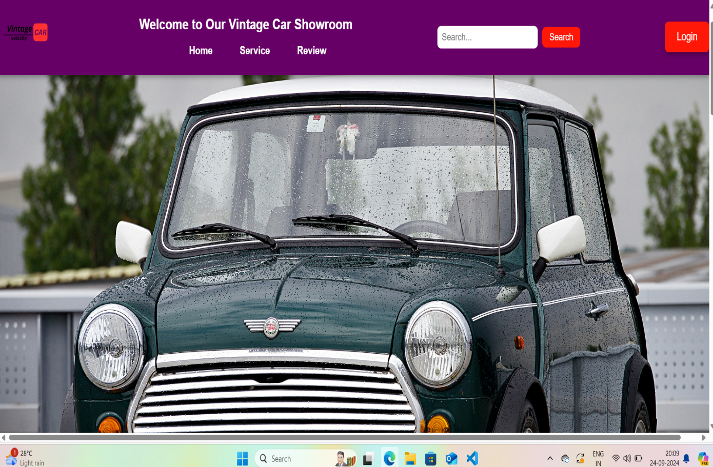

**Home Page:**

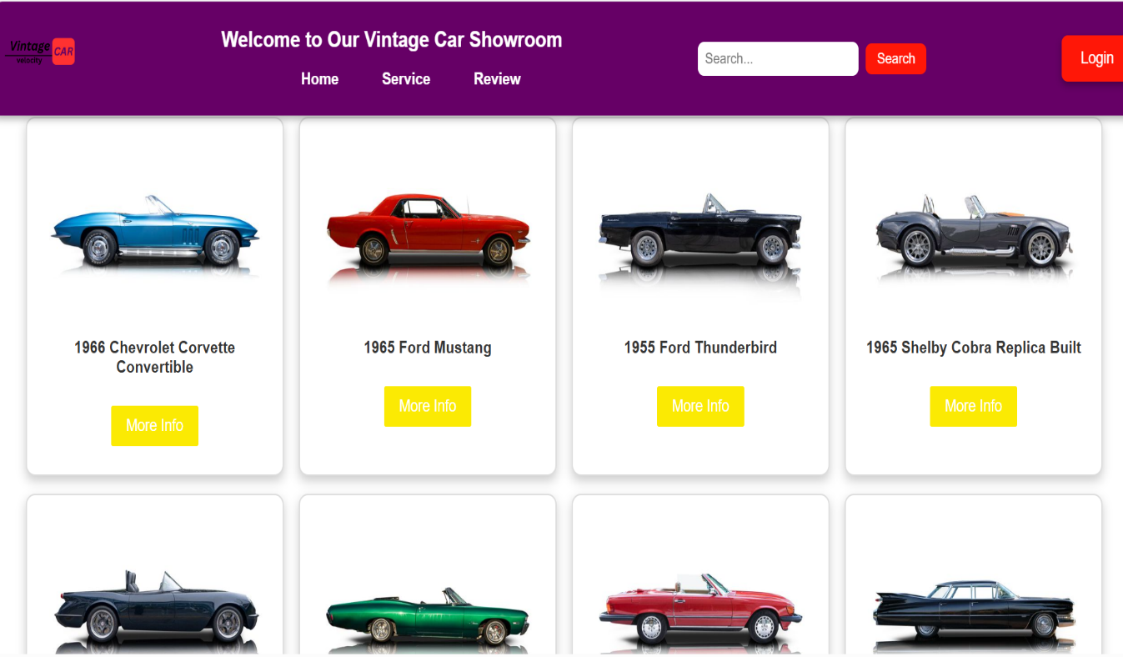

**Car Details:**

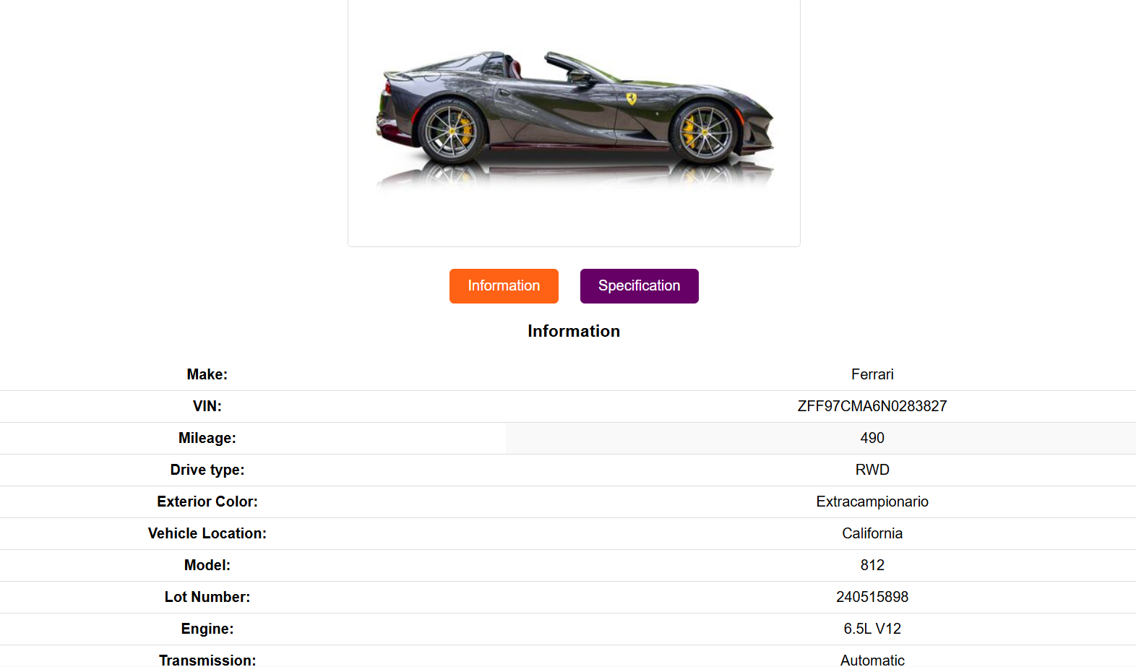

**Service Details:**

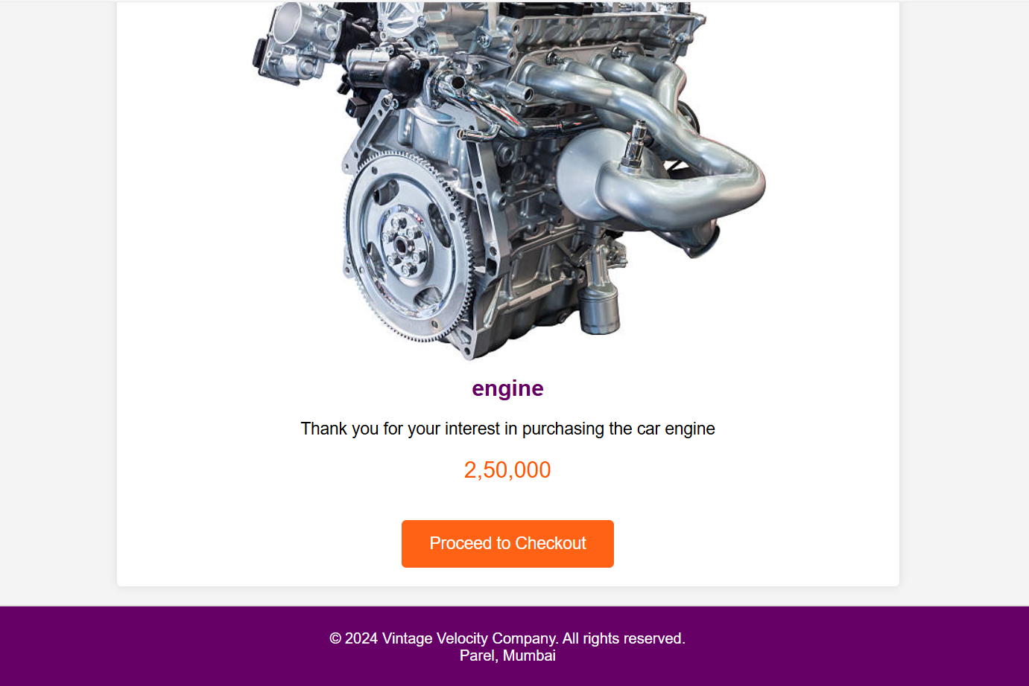

**Review Page:**

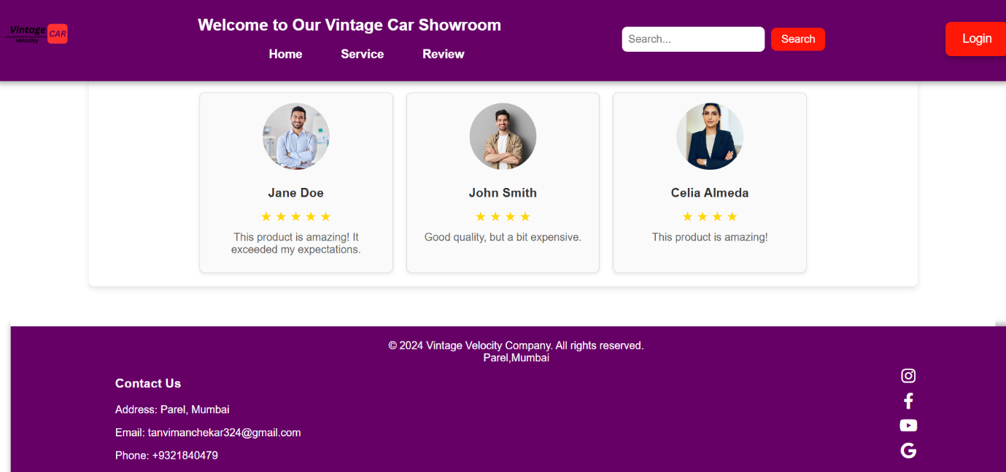

**Contact Page:**

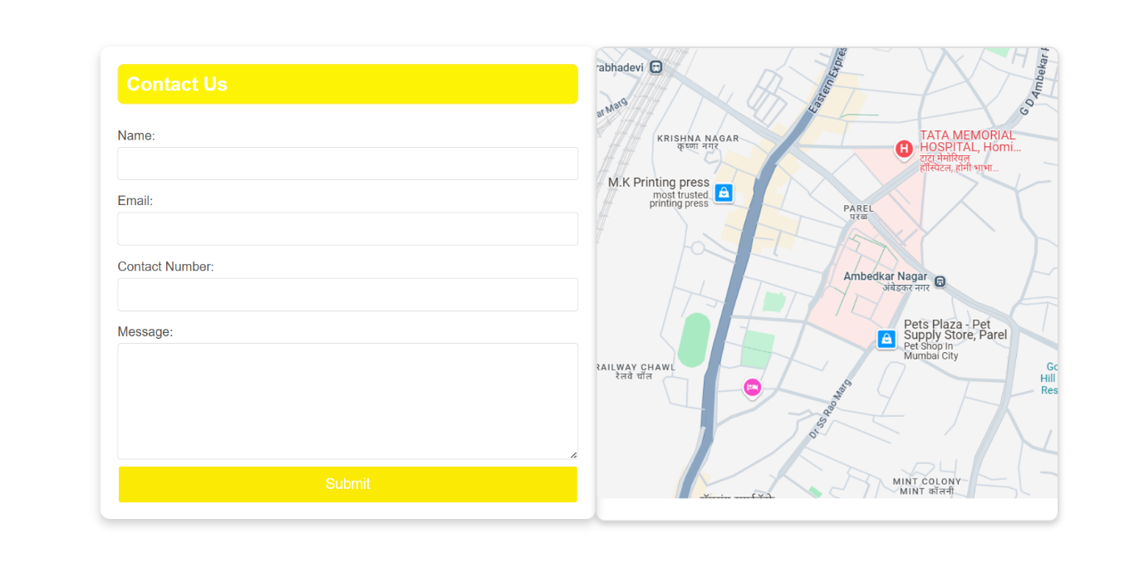

**Login Page:**

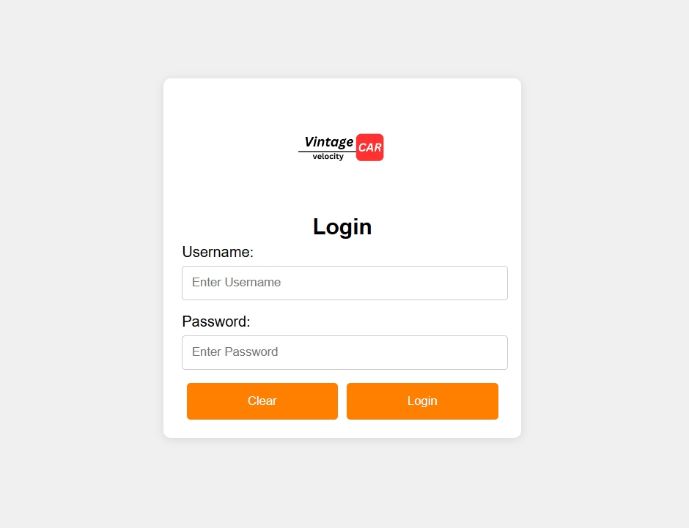

**About Us:**

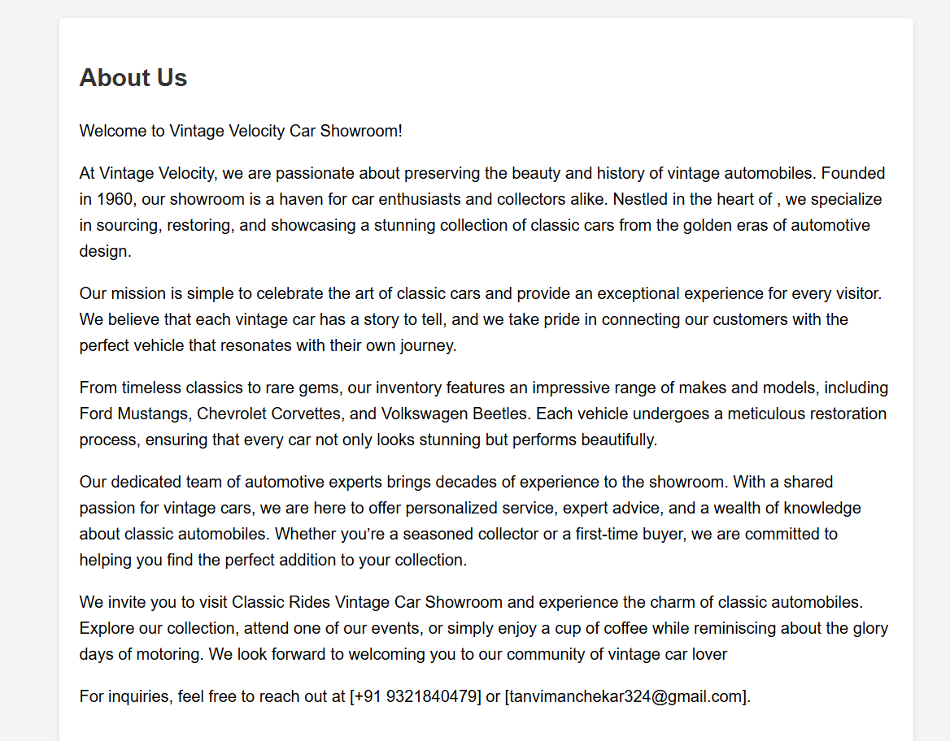

**Frequently Asked Question:**

